SUNY Adirondack Student Accounts/Bursar

640 Bay Road, Queensbury, NY 12804-1445| 518.743.2266 | [studentaccounts@sunyacc.edu](mailto:studentaccounts@sunyacc.edu)

# Student Banner 9

Banner is the college’s student information system. Here you can obtain your login information, register for courses, print class schedules, review and pay your student bill, find the necessary access information for the campus wireless network and check your paystub if you are a student employee.

To log into Banner, you will go through the [MYSUNYADK student portal](https://www.mysunyadk.com/) using your Network ID and password. Then select the Banner link from the menu at the top of the page.

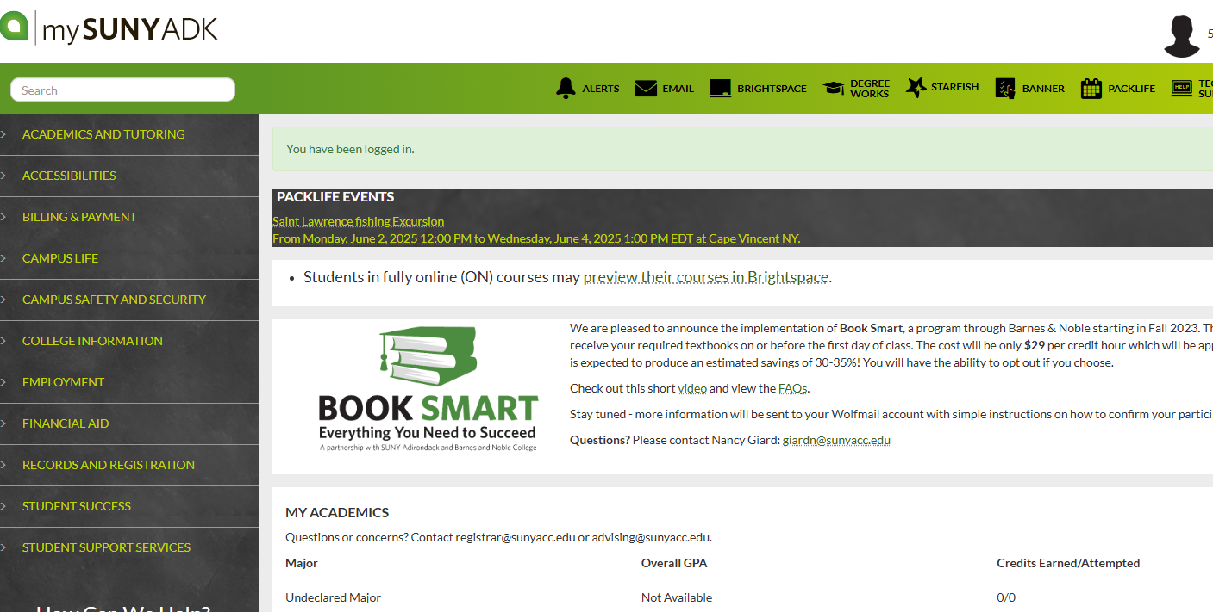

If you have any questions about navigating Banner, please contact:

Student Accounts: [studentaccounts@sunyacc.edu](mailto:studentaccounts@sunyacc.edu)   
Financial Aid: [finaidoffice@sunyacc.edu](mailto:finaidoffice@sunyacc.edu)  
Student Success: [advising@sunyacc.edu](mailto:advising@sunyacc.edu)  
Help Desk: [help@sunyacc.edu](mailto:help@sunyacc.edu)

Additional information about your SUNY Adirondack accounts is available via the SUNY Adirondack [technology page](https://www.sunyacc.edu/suny-adirondack-technology) of the website.

# Navigating the Student Account Section in Student Banner 9

SUNY Adirondack Student Accounts/Bursar

640 Bay Road, Queensbury, NY 12804-1445| 518.743.2266 | [studentaccounts@sunyacc.edu](mailto:studentaccounts@sunyacc.edu)

The Student Account Section is organized into a series of tabs that guide you through the information and actions you may need to take.

1. Pay Your Bill

2. Refunds

3. 1098T

4. Certificate of Residence - COR

## 1. Accessing the Pay Your Bill Dashboard

After logging in, select “Student Account” from the [Student Services menu](https://banner.sunyacc.edu/StudentSelfService/ssb/studentCommonDashboard).

Student account by term

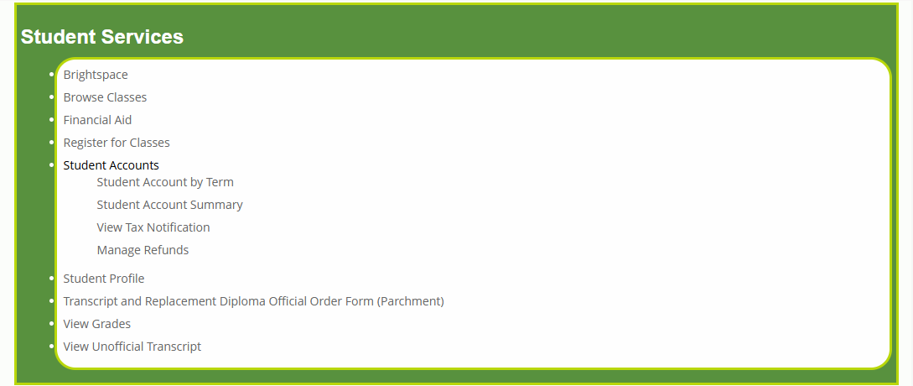

Select Term

Click [pay now](https://app1.campuscommerce.com/api/connector/saml/ent/36882)

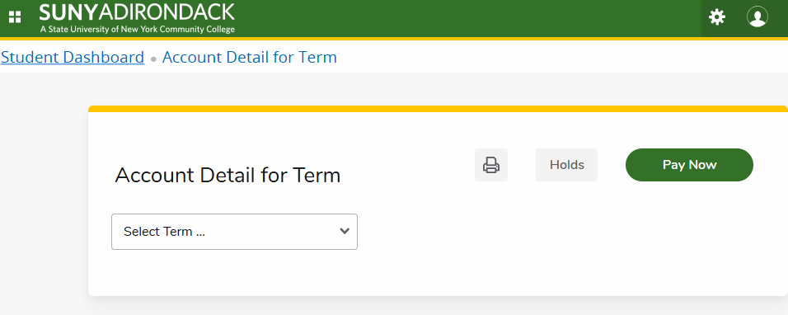

AUTHORIZED PARTY TO PAY – If someone other than the student is paying or setting up a payment plan, the student has to first authorize the party to do so. The student signs in following the above directions. Then look for add an authorized party and follow the steps.

The authorized party will then receive an email with a customer # - click to go to Nelnet, follow the instructions. Once done, they will have created a passcode. The authorized party will need to keep the original link from the email to sign back in at a later date. (If they do not have it, the student will need to reissue the invite)

2. Refunds – issued through Nelnet (choice of direct deposit, check, or prepaid debit card)

After logging in, select “Student Account” from the Student Services menu

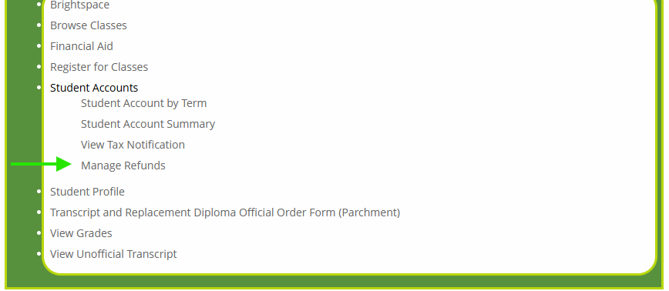

Pay your current Term

Refund management on right hand side

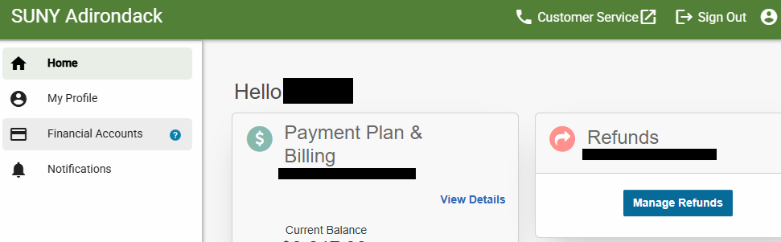

If you have problems with the Nelnet portal, call Nelnet customer service: 1-800-609-8056

## 3. 1098T (year end tax information)

After logging in, select “Student Account” from the Student Services menu

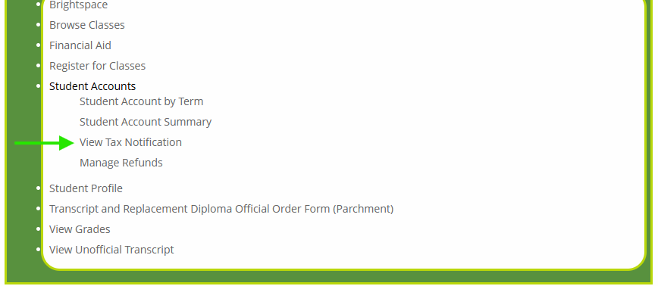

View Tax notification

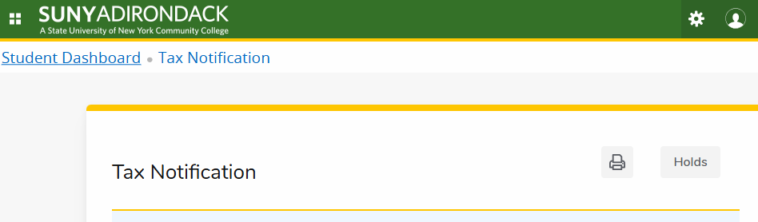

## 4. Certificate of Residence – COR

Go to [In-state residency | SUNY Adirondack](https://sunyacc.edu/admissions-aid/tuition-and-fees/state-residency)

Warren and Washington County students download the COR form

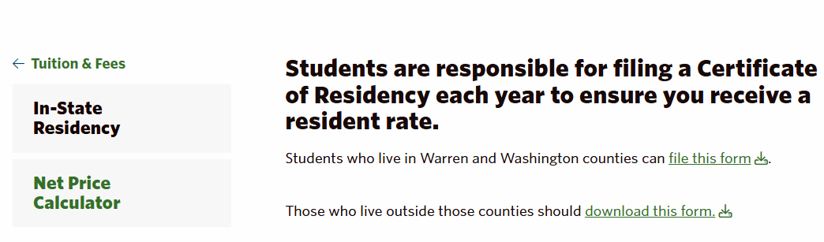

Other counties go to those who live outside those counties should download this form and click the link

Warren and Washington County students complete and submit form to the student accounts office

Other Counties - complete and submit application to your county treasurer Obtain the actual certificate from your county treasurer Submit the COR to the Student Accounts/Bursars office

Ways to submit:

* Scan and email to [studentaccounts@sunyacc.edu](mailto:studentaccounts@sunyacc.edu)
* Drop it off in person to the Bursar’s/Student Accounts/Business Office in Warren Hall on our Queensbury campus 640 Bay Road
* Mail it to Student Account/Bursar Office, Bay Road, Queensbury, NY 12804

**Contact Student Accounts if you have questions about your bill or a hold on your account

518.743.2266 | [studentaccounts@sunyacc.edu](mailto:studentaccounts@sunyacc.edu)