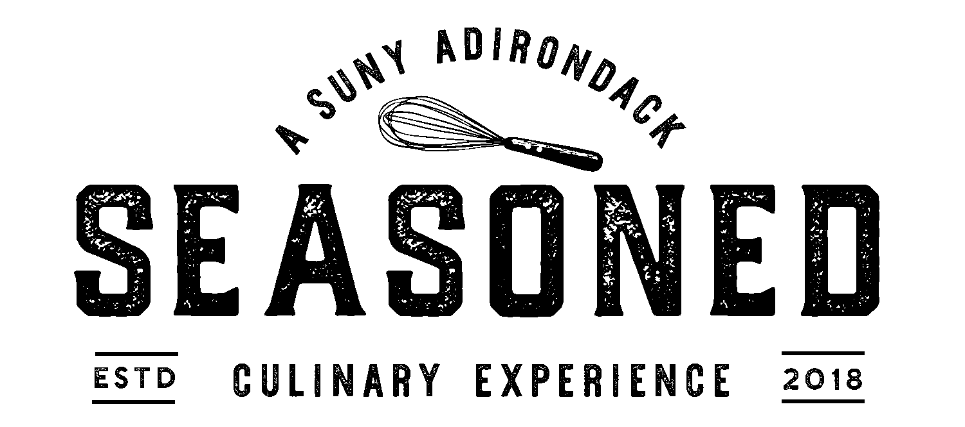

Dinner $26.95 + Tax ~ Chef Selection Wine or Beer Pairing Additional $18

Amuse

Appetizers
Summer Crisp Lettuce | Dried Cranberries | Cabot Cheddar | Praline | Balsamic Vinaigrette [*V, GF]
Paired with Vidal-Fleury Côtes du Rhône 2017 or Common Roots Lager

Shaved Radish | Carrot | Herb Chevre | Lemon Vinaigrette [*V, GF]
Paired with Joel Gott Sauvignon Blanc 2021 or Common Roots Good Fortune

Winter Squash Bisque | Maple Crema [V, GF]
Paired with Josh Cellars Buttery Chardonnay 2020 or 1911 Original Cider

Grilled Peaches | Crisp Fennel | Red Onion | Spicy Pepper Relish | Shrimp | Honey | Lemon [*V, GF]
Paired with Joel Gott Sauvignon Blanc 2021 or Northway Brewing Miracle On Ice

Intermezzo
Lemon [GF, *V]

Entrees
Braised Short Plate Ribs | Yukon Mash | Rainbow Carrots | Red Wine Demi Glace [GF]
Paired with Block Nine Cabernet Sauvignon 2020 or Mean Max Six & Change

Roasted Airline Chicken Breast | Sweet Potato Puree | String Beans | Sage Au Jus [GF]
Paired with Vidal-Fleury Côtes du Rhône 2017 or Common Roots Good Fortune

Faroe Island Salmon | Roasted New Potatoes | Charred Leeks | Mustard Beurre Blanc [GF]
Paired with Josh Cellars Buttery Chardonnay 2020 or Common Roots Good Fortune

Eggplant | Summer Squash | Lemon Herb Ricotta | Fettuccine | Marinara [*V, *GF]
Paired with Block Nine Cabernet Sauvignon 2020 or Mean Max Six & Change

Please alert your server of any dietary restrictions or allergies before ordering.
[GF = gluten free] [*GF = can be gluten free] [V = vegetarian] [*V = can be vegan]
Fine dining effective dinner Oct. 12, 2022
Thank you to our local farm partners:
Old World Farm (Stillwater) | Fresh Take Farm (Argyle) | Pleasant Valley Farm (Argyle) |
Kilcoyne Farm (Hudson Falls) | Whitefield’s Farm (Athol)
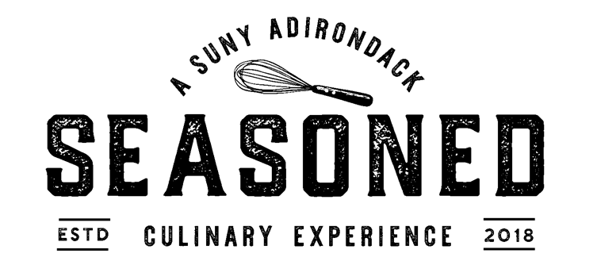

Desserts
Dark Chocolate Torte | Mirror Glaze | Raspberry Sauce [GF, V]
Paired with Block Nine Cabernet Sauvignon 2020 or Mean Max Six & Change

Buttermilk Panna Cotta | Brown Sugar Cinnamon Streusel | Apple Compote [*GF, V]
Paired with Josh Cellars Buttery Chardonnay 2020 or 1911 Original Cider

Maple Sorbet | Pecan Praline [GF, *V]
Paired with Josh Cellars Buttery Chardonnay 2020 or 1911 Original Cider

Compressed Watermelon | Compressed Cucumber | Mint | Frozen Sea Salted Yogurt [GF, *V]
Paired with Joel Gott Sauvignon Blanc 2021 or Common Roots Great Vibes

Please alert your server of any dietary restrictions or allergies before ordering.
[GF = gluten free] [*GF = can be gluten free] [V = vegetarian] [*V = can be vegan]
Fine dining effective dinner Oct. 12, 2022

