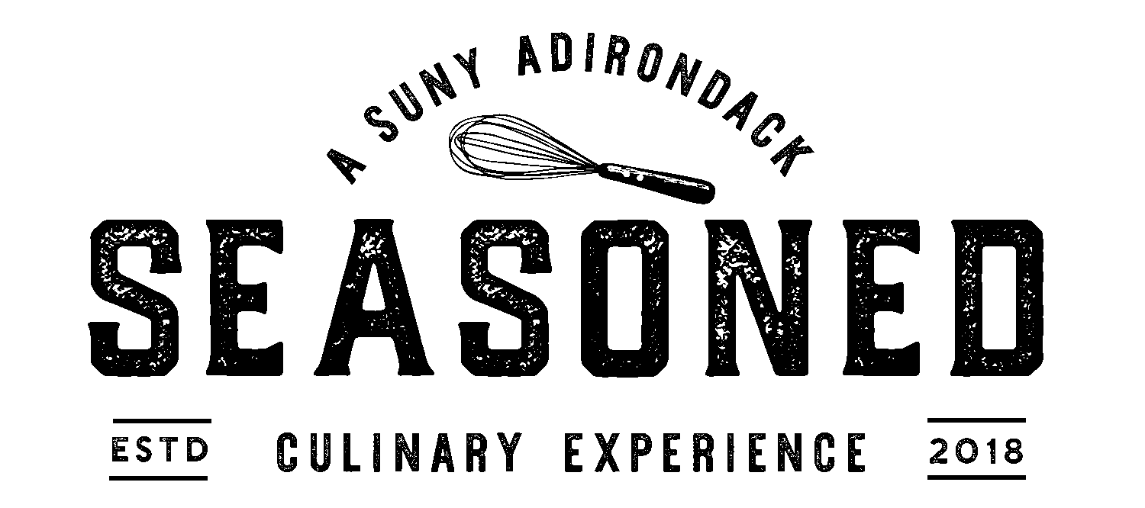
Choice of Appetizer, Entrée, Dessert and Non-Alcoholic Beverage
$15.95 plus tax

February 24th & 25th 2021

Appetizers
Cream of Broccoli and Cheddar Soup
Or
Caesar Salad

Entrees
Fish Du Jour Meuniere
over basmati rice with steamed asparagus and pickled red onions
Or
Chicken
with tomatoes, mushrooms and Hungarian potatoes

Desserts
Please Ask Your Server About Our Desserts Du Jour
Prepared By Our Baking Classes

Beverages
Soda, Iced Tea, Hot Tea and Coffee

Cash Bar
Local Craft Beer and Wine

*A house garden salad can substitute appetizer choice*
*Please alert your server of any allergies or dietary restrictions*

