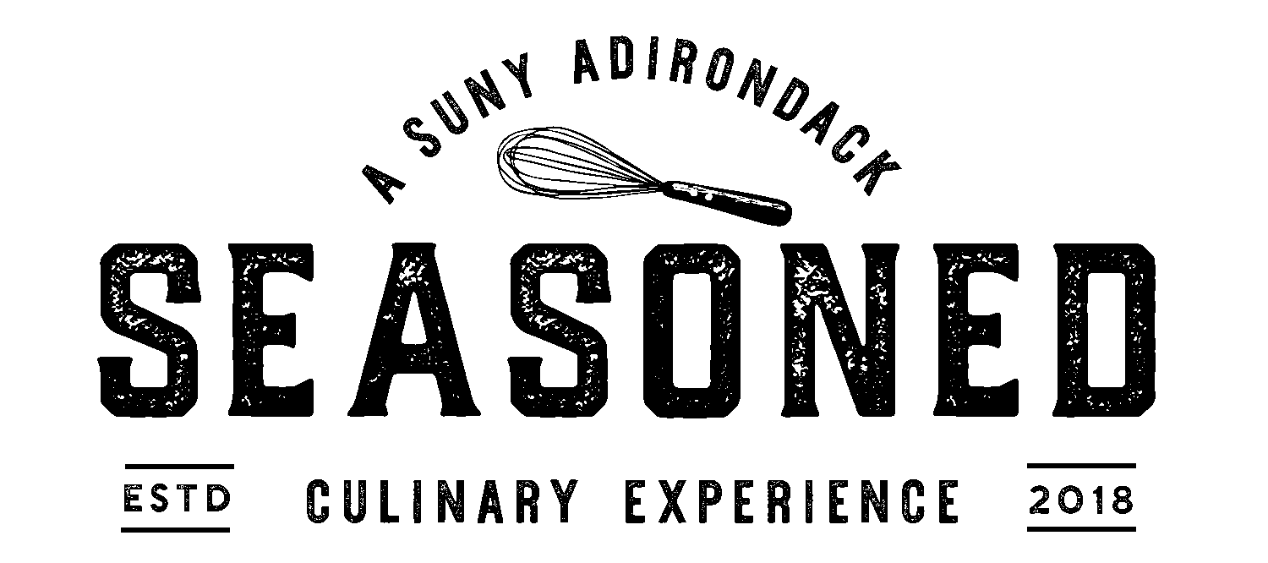

Wines (glass/bottle):

Vidal-Fleury Côtes du Rhône 2017
(France)
$10/$42

Ruvei Marchesi Di Barolo 2018
(Italy)
$12/$48

Joel Gott Sauvignon Blanc 2021
(New Zealand)
$14/$55

Block Nine Cabernet Sauvignon 2020
(California)
$10/$42

Josh Cellars Buttery Chardonnay 2020
(California)
$9/$37

Victory View Revolution Marquette
(New York)
$9/$37

Josh Prosecco
(Italy)
$10/$42

Local breweries on tap by the pint:

Northway Brewing Miracle On Ice
Style: Golden Ale
5.5% (Queensbury, New York) $8

Common Roots Good Fortune
Style: IPA
6.5% (South Glens Falls, New York) $8

Common Roots Great Vibes
Style: Sour
5.8% (South Glens Falls, New York) $8

Mean Max Six & Change
Style: Brown Ale
6.2% (Glens Falls, New York) $8

Common Roots Lager
Style: Lager
5.2% (South Glens Falls, New York) $8

1911 Original Cider
Style: Hard Cider
5.5% (Lafayette, New York) $8

Craft Beer Flights — choice of four: $14

Assorted Hot Tea, Regular Coffee, Decaf Coffee $2

Included with your experience:
Pepsi, Diet Pepsi, Sierra Mist, Ginger Ale, unsweetened iced tea, lemonade

