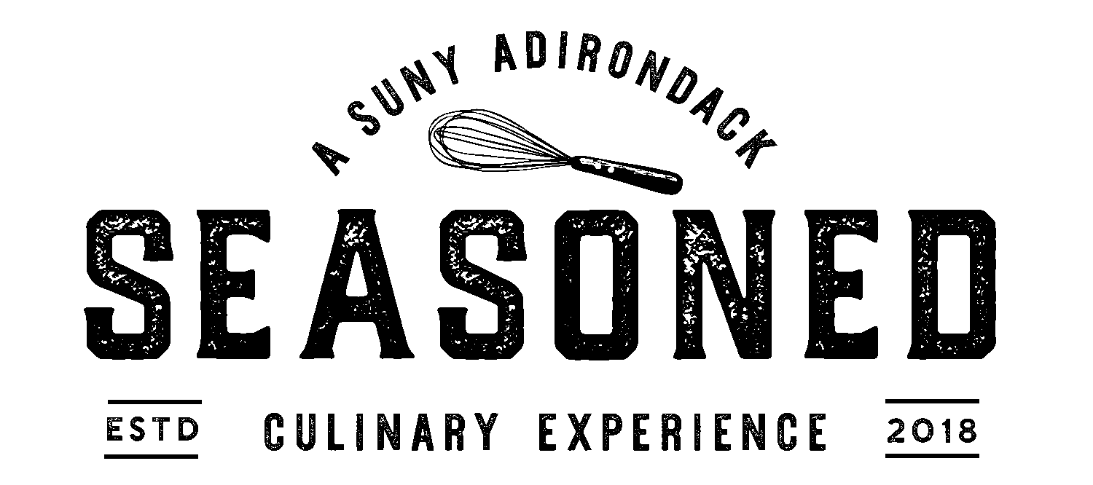

Appetizers
Chilled Grilled Shrimp . Charred Peach . Asian Greens . Spicy Pepper Relish [GF]
Paired with ~ Victory View Vineyard Abigail La Crescent 2017 or Common Roots Original Concept IPA

Roasted Root Vegetables . Ginger Salsa Verde [GF, V]
Paired with ~ Josh Chardonnay 2018 or Adirondack Brewery Bear Naked Amber Ale

Pumpkin Soup . Toasted Pepitas . Cinnamon [GF, *V]
Paired with ~ Josh Chardonnay 2018 or Saratoga Apple Cider

Carpaccio of Beef . Truffle Salted Cherry Tomatoes . Greens . Horseradish Powder [GF]
Paired with ~ Joseph Carr Cabernet Sauvignon 2017 or Northway Brewing Perfect Day Pilsner

Green Salad . Balsamic Vinaigrette . Fresh Local Harvest Vegetables [GF, V]
Paired with ~ Santi - "Sortesele" Pinot Grigio Valdadige 2018 or Northway Brewing Perfect Day Pilsner

Entrees
Braised Lamb . Cumin . Roasted Potato . Burnt Onion . Spinach . Carrots [GF]
Paired with ~Victory View Vineyard Turning Point Marquette or Adirondack Brewery Bear Naked Amber Ale

48 Hour Sous Vide Beef Short Rib . Sweet Potato Puree . Root Vegetables . Au Jus [GF]
Paired with ~ Joseph Carr Cabernet Sauvignon 2017 or Common Roots Snowy Night DBL Stout

Pan Seared Salmon . Saffron Beurre Blanc . Asian Greens . Radish . Basmati Rice [GF]
Paired with ~ Josh Chardonnay 2018 or Adirondack Brewery Bear Naked Amber Ale

Red Chicken . Asian Greens . Rice Noodles . Baby Roasted Corn [GF]
Paired with ~ Santi - "Sortesele" Pinot Grigio Valdadige 2018 or Common Roots Original Concept IPA

Beyond Meat Burger . Fennel Mustard . Greens . Tomato . Pickled Red Onion . Roll Du Jour
Beet Tarragon Salad . Pommes Frites [*GF, V]
Paired with ~ Santi - "Sortesele" Pinot Grigio Valdadige 2018 or Adirondack Brewery Bear Naked Amber Ale

Stir Fried Garden Vegetables . Marinated Tofu . Rice Noodles . Soy Foam [GF, V]
Paired with ~ Victory View Vineyard Abigail La Crescent 2017 or Common Roots Original Concept IPA

Please Alert Your Server of Any Dietary Restrictions or Allergies Before Ordering
[GF= Gluten Free] [*GF= Can Be Gluten Free] [V= Vegetarian]

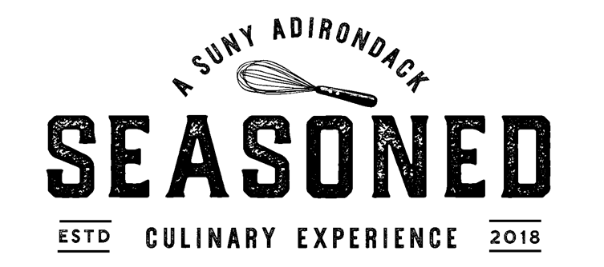

Desserts
Flourless Dark Chocolate Torte . Berry Coulis [GF]
Paired with ~ Joseph Carr Cabernet Sauvignon 2017 or Common Roots Snowy Night DBL Stout

House made Sea Salted Vanilla Bean Ice Cream [GF]
Paired with ~ Victory View Vineyard Abigail La Crescent 2017 or Common Roots Snowy Night DBL Stout

Crème Brule [GF]
Paired with ~ Victory View Vineyard Abigail La Crescent 2017 or Common Roots Snowy Night DBL Stout

Raspberry Sorbet . Beet Meringue [GF, *V]
Paired with ~ Victory View Vineyard Abigail La Crescent 2017 or Saratoga Apple Cider

Cinnamon Puff Pastry . Brown Sugar Stewed Apples . Cider Pearls
Paired with ~ Victory View Vineyard Abigail La Crescent 2017 or Saratoga Apple Cider

Please Alert Your Server of Any Dietary Restrictions or Allergies Before Ordering
[GF= Gluten Free] [*GF= Can Be Gluten Free] [V= Vegetarian]

