Howl Trivia Night
Friday, March 3, 2017
5:00pm – Registration
5:30 – 6:30 Buffet & Cash Bar
6:30 – 8:30pm -Trivia Contest

Great Escape Lodge
Conference Center
89 Six Flags Dr – Queensbury, NY

Proceeds benefit scholarships
at SUNY Adirondack
Entertainment provided by DJ Luny Tunz

  - Team Sign Up
Team Captain -
Player 2 -
Player 3 -
Player 4 -
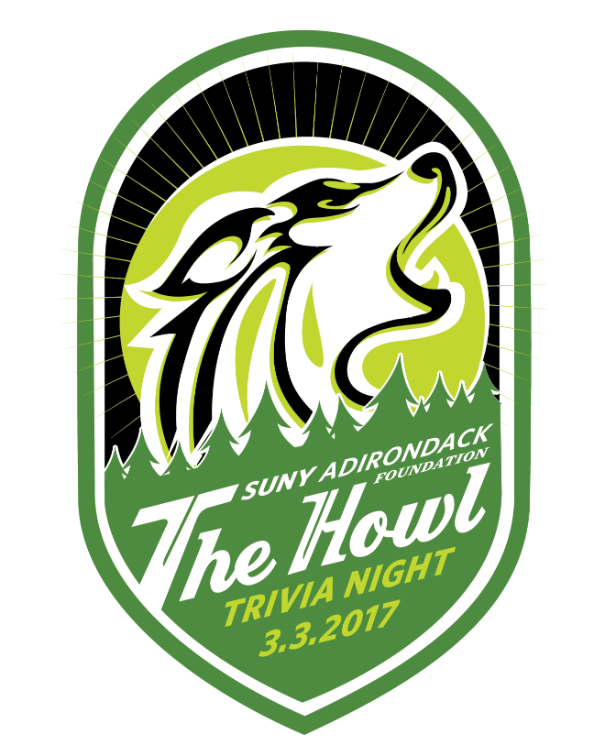
Player 5 -
Player 6 -
Team Sponsor Business Name/Team Name:
Payment Method (mark X on one): Cash Check
Credit Card (go to sunyacc.edu\trivia)
Billing Address:

Billing phone number:
Billing e-mail:
Credit card payments can be made on the Foundation’s website - sunyacc.edu/trivia
Mail completed form to: foundation@sunyacc.edu or SUNY Adirondack Foundation, 640 Bay Road, Queensbury, NY 12804

