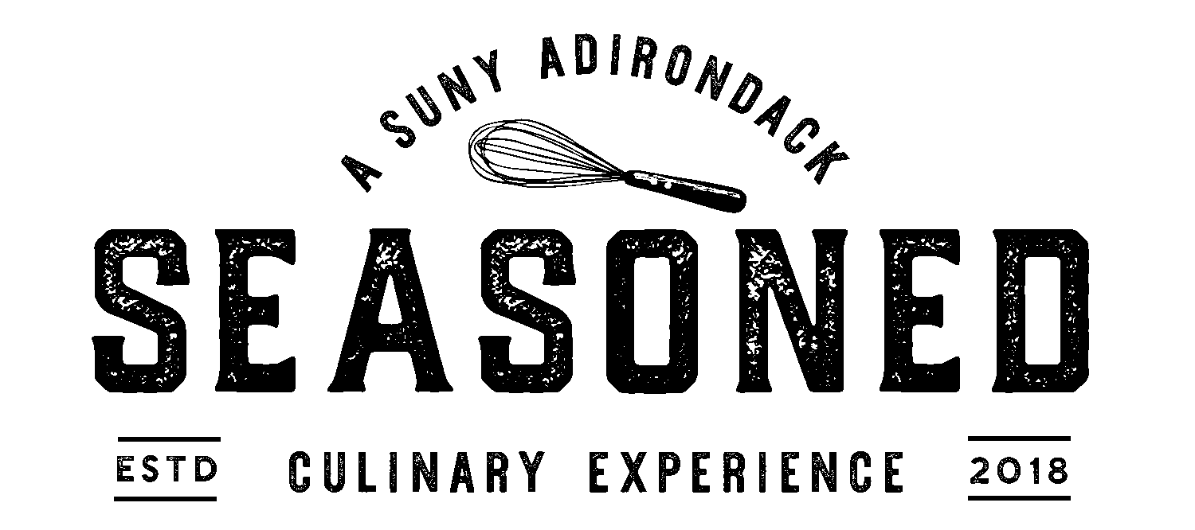

Appetizers
Pumpkin Soup . Adirondack Maple Crema [GF, *V]

Artisanal Greens . Dried Cranberries . Blue Cheese . Praline . Balsamic Vinaigrette [GF, *V]

Beets . Chevre . Orange Supreme . Tarragon Sherry Vinaigrette [GF, *V]

“Poutine” . Frites . Confit Duck . Cabot Cheddar . Gravy . Sea Salted Duck Fat Powder [GF]

Entrees
Cast Iron Seared Duck Breast . Nutmeg Sweet Potato Puree . Cranberry Apple Relish . Sourdough Stuffing . Sage Gravy [*GF]

Shrimp . Grits . House Andouille Sausage . Fried Okra . Spinach Dashi [GF]

Lamb Bolognese . Penne . Smoked Beef Bacon . Mire Poix . Parm Crisp [GF]

Buttermilk Fried Chicken Thigh . Butternut Squash Risotto . Swiss Chard .
Mustard Beurre Blanc [*GF]

Maple Tofu . Nutmeg Sweet Potato Puree . Cranberry Apple Relish . Sourdough Stuffing . Mushroom Gravy [GF, *V]

Beyond Meat Bolognese . Penne . Parm Crisp . Mire Poix [GF, *V]

Desserts
Please Ask Your Server About Our Desserts Du Jour

Please Alert Your Server of Any Dietary Restrictions or Allergies Before Ordering
[GF= Gluten Free] [*GF= Can Be Gluten Free] [V= Vegetarian] [*V= Can Be Vegan]
Effective Lunch 11/18/2020 & Dinner 11/19/2020

