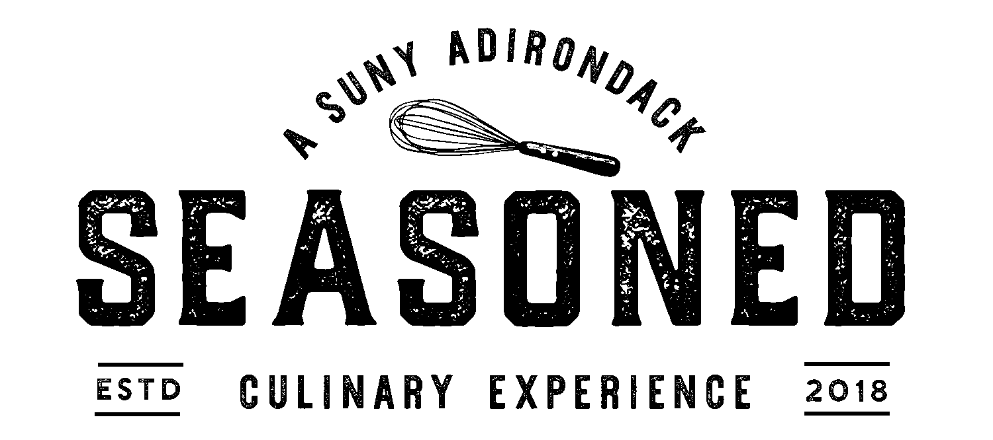

Appetizers
Pumpkin Soup . Adirondack Maple Crema [GF, *V]
Paired with ~ Josh Chardonnay 2018 or Adirondack Brewery Bear Naked Amber Ale

Beets . Chevre . Orange Supreme . Tarragon Sherry Vinaigrette [GF, *V]
Paired with ~ Santi - "Sortesele" Pinot Grigio Valdadige 2018 or Common Roots Original Concept IPA

Artisanal Greens . Dried Cranberries . Blue Cheese . Praline . Balsamic Vinaigrette [GF, *V]
Paired with ~ Joseph Carr Cabernet Sauvignon 2017 or Northway Brewing Perfect Day Pilsner

“Poutine” . Frites . Confit Duck . Cabot Cheddar . Gravy . Sea Salted Duck Fat Powder [GF]
Paired with ~ Corbiante Syrah Malvasia Nera 2017 or Artisanal Brew Works B. B. Brown

Entrees
Cast Iron Seared Duck Breast . Nutmeg Sweet Potato Puree . Cranberry Apple Relish . Sourdough Stuffing . Sage Gravy [*GF]
Paired with ~ Corbiante Syrah Malvasia Nera 2017 or Adirondack Brewery Bear Naked Amber Ale

Shrimp . Grits . House Andouille Sausage . Fried Okra . Spinach Dashi [GF]
Paired with ~ Josh Chardonnay 2018 or Northway Brewing Co. Perfect Day Pilsner

Lamb Bolognese . Penne . Smoked Beef Bacon . Mire Poix . Parm Crisp [GF]
Paired with ~ D'Arenberg Stump Jump GSM 2016 or Common Roots Snowy Night DBL Stout

Buttermilk Fried Chicken Thigh . Butternut Squash Risotto . Swiss Chard .
Mustard Beurre Blanc [*GF]
Paired with ~ Victory View Vineyard Abigail La Crescent 2017 or Adirondack Brewery Bear Naked Amber Ale

Maple Tofu . Nutmeg Sweet Potato Puree . Cranberry Apple Relish . Sourdough Stuffing .
Mushroom Gravy [GF, *V]
Paired with ~ Corbiante Syrah Malvasia Nera 2017 or Adirondack Brewery Bear Naked Amber Ale

Beyond Meat Bolognese . Penne . Parm Crisp . Mire Poix [GF, *V]
Paired with ~ D'Arenberg Stump Jump GSM 2016 or Common Roots Snowy Night DBL Stout

Please Alert Your Server of Any Dietary Restrictions or Allergies Before Ordering
[GF= Gluten Free] [*GF= Can Be Gluten Free] [*V= Vegetarian & Can Be Vegan]
Effective Dinner 11/18/2020
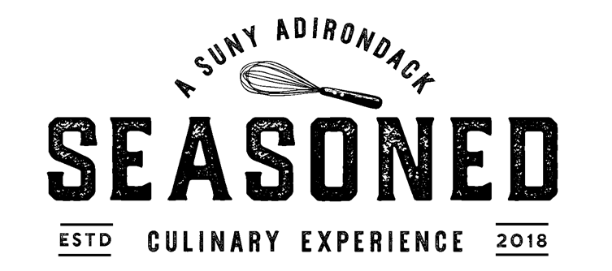

Desserts
"Plaintan Fosters"
Brown Sugar Sauteed Plantains . Vanilla Ice Cream . Crisp Plantain [GF, V]
Paired with ~ Victory View Vineyard Abigail La Crescent 2017 or Common Roots Snowy Night DBL Stout

Dark Chocolate Torte . Raspberry Sauce . Mint Sorbet [GF, V]
Paired with ~ Joseph Carr Cabernet Sauvignon 2017 or Common Roots Snowy Night DBL Stout

Milk Chocolate Cup . Peanut Butter Mousse [GF]
Paired with ~ Joseph Carr Cabernet Sauvignon 2017 or Artisanal Brew Works B. B. Brown

Raspberry Sorbet . Blueberry Sorbet . Mint Sorbet [GF, *V]
Paired with ~ Corbiante Syrah Malvasia Nera 2017 or Saratoga Apple Cider

Please Alert Your Server of Any Dietary Restrictions or Allergies Before Ordering
[GF= Gluten Free] [*GF= Can Be Gluten Free] [*V= Vegetarian & Can Be Vegan]

Effective Dinner 11/18/2020 - Dinner 11/19/2020

