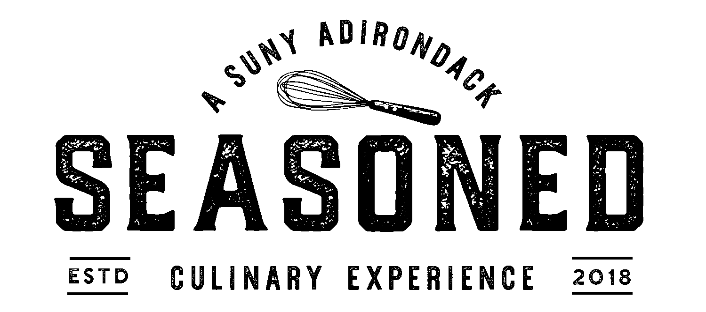

Dec. 2, 2021

French Onion Soup
$6

Roasted Potato and Shaved Fennel Salad
Potatoes | Fennel | Capers | Orange Thyme Vinaigrette
$6

Babaganoush
Cucumbers | Peppers | Naan
$6

Croque Monsieur (or Madame, with fried egg)
Ham | Gruyere | Pullman Bread | Dijon | Kettle Chips
$10

Curry Chicken Salad Sandwich
Curry Chicken | Apples | Greens | Toasted Cashews | Kettle Chips
$10

Beverages
Pepsi | Diet Pepsi | Sierra Mist | Ginger Ale | Lemonade | Unsweetened Iced Tea $1.25
Assorted Hot Herbal Tea $2
Regular Coffee $2.50 | Decaf Coffee $2.50

