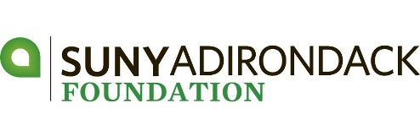
lyman a. beeman, jr. golf tournament
APPLICAtion for ENTRY – JUNE 16, 2017

DATE | Friday, June 16, 2017 (Kindly register by June 9)
TIME | Registration & Lunch begin at 11:30 am  Shotgun Start – 1:00 pm
PLACE | Hiland Park Country Club – 195 Haviland Rd - Queensbury
ENTRY FEE | $600 – Foursome $150 – Individual Player
 | Includes: lunch, golf, cart, driving range, gift & cocktail reception
FORMAT  PRIZES | Four Person Scramble  Tournament Low Gross | 1st – 2nd – 3rd Place Net  Low Women’s Net  Longest Drive Men and Women  Closest to the Pin Men and Women  Putting Contest and Raffle
Thank you to our Post-Doctoral Sponsor:

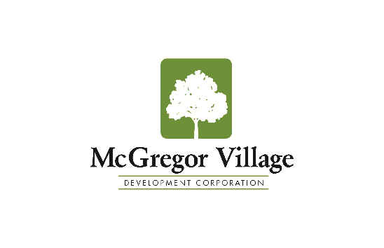
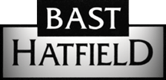
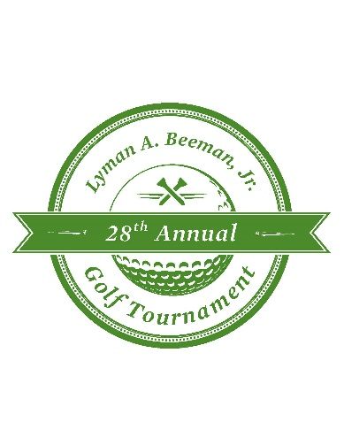
Thank you to our Doctoral Sponsors:
Company/Team Name
Captain – Player #1 |  | Handicap -
E-mail Address
Address
City, State, Zip Code
Phone
Sponsorship
Amount Enclosed
Make check payable to: SUNY Adirondack Foundation OR make a secure credit card payment at sunyacc.edu/beemangolf

Tax Deduction - $60 per player – FEDERAL TAX ID # 22-2486001 REGISTRATION DEADLINE – June 9, 2017

Player Name | Handicap | Home Address
#2
e-mail -
#3
e-mail -
#4
e-mail -

ALL PROCEEDS HELP SUPPORT STUDENT SCHOLARSHIPS
AT
SUNY ADIRONDACK

FOR MORE INFORMATION
Web: sunyacc.edu/beemangolf
Phone: 518-743-2243
E-mail: foundation@sunyacc.edu
For your convenience:
A fillable Registration Form is available online at sunyacc.edu/beemangolf

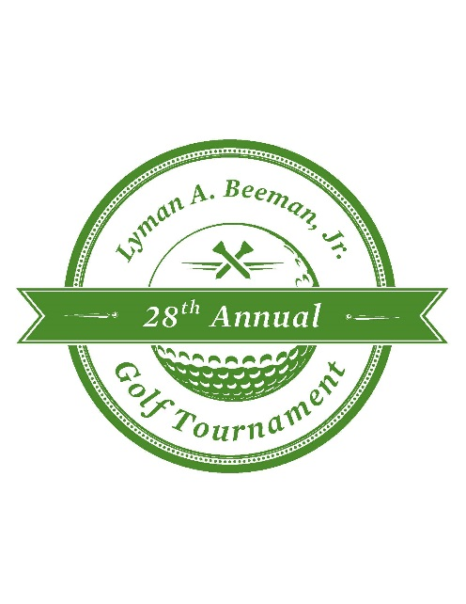
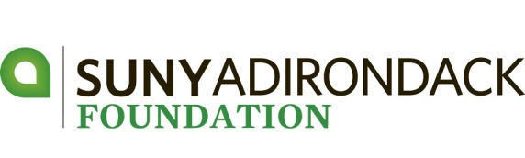

Sponsorship Levels - 2017

Post-Doctoral Sponsor - $4,000
- One $500 scholarship in your company’s name to a student in 2017 - 2018
- One foursome
- Logo on a tournament gift & player gift bags
- Logo on the Save-the-Date card & Registration Form; recognition in tournament program and website
Doctoral Sponsor - $2,500
- One $500 scholarship in your company’s name to a student in 2017-2018
- One foursome
- Sponsor of golf carts
- Logo on the Save-the-Date and Registration Form; recognition in tournament program and website

Master Sponsor - $2,000
- Sponsor of lunch, beer and water stations
- One foursome
- Recognition in tournament program and website

Bachelor Sponsor - $1,500
- Sponsor of Awards Cocktail Reception
- One foursome
- Signage on course, recognition in tournament program and website

Associate Sponsor - $1,000
- Signage at the practice green and putting contest
- One foursome
- Recognition in tournament program and website

Hole-in-One Sponsor - $600 or Barter
- Signage for a hole-in-one prize at a single par 3
- Two golfers
- Recognition in tournament program and website

Prize Sponsor - $300
- Company logo on prize envelopes for winners
- Recognition in tournament program and website

Tee Sign - $150
- Signage on course and recognition in the tournament program

