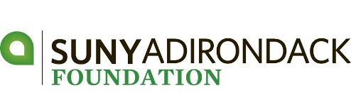
lyman a. beeman, jr. golf tournament
APPLICAtion for ENTRY – JUNE 1, 2018

DATE | Friday, June 1, 2018 (Kindly register by May 25)
TIME | Registration & Lunch begin at 11:30 am Shotgun Start – 1:00 pm
PLACE | Hiland Park Country Club – 195 Haviland Rd - Queensbury
ENTRY FEE | $640 – Foursome $160 – Individual Player
 | Includes: lunch, golf, cart, driving range, gift & cocktail reception
FORMAT  PRIZES | Four Person Scramble  Tournament Low Gross | 1st – 2nd – 3rd Place Net  Low Women’s Net | Longest Drive Men and Women  Closest to the Pin Men and Women  Putting Contest and Raffle
NEW THIS YEAR  SUPER TICKET | Include $30 in your registration fee (per player). This entitles each player to a gimmee, putting contest and 50 PICK-A-PRIZE raffle stubs. Tickets will be handed out during registration.

Thank you to our Post-Doctoral Sponsor:

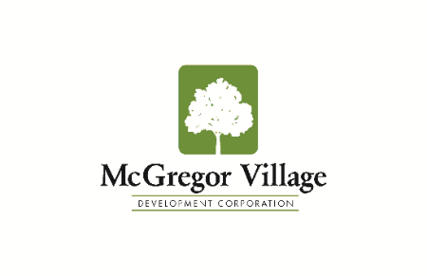
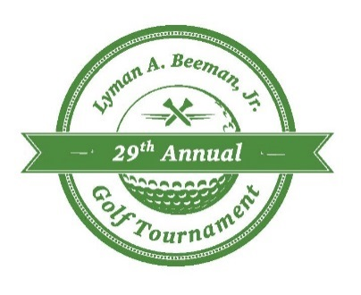
Thank you to our Doctoral Sponsors:
Company/Team Name
Captain – Player #1 |  | Handicap -
E-mail Address
Address
City, State, Zip Code
Phone
Sponsorship
Amount Enclosed
Make check payable to: SUNY Adirondack Foundation OR make a secure credit card payment at sunyacc.edu/beemangolf

Tax Deduction - $70 per player – FEDERAL TAX ID # 22-2486001 REGISTRATION DEADLINE – May 25, 2018

Player Name | Handicap | PAYMENT INFORMATION
#2 |  | Enclosed please find payment:  ☐$640 – Foursome  ☐$760 – Includes Foursome $640 and SUPER TICKET ($30 per player):  - Gimmee  - Putting Contest  - 50 Pick-A-Prize Raffle Stubs  ☐$______________ – Sponsor (Circle One)  Doctoral ($2,500) | Master ($2,000) | Bachelor ($1,500  Associate ($1,200) | Hole-in-One ($750) | Prize ($300)  ☐$200 – Tee Sign  ☐$160 player ☐$30 SUPER TICKET
e-mail -
#3
e-mail -
#4
e-mail -
ALL PROCEEDS HELP SUPPORT STUDENT SCHOLARSHIPS
AT
SUNY ADIRONDACK

FOR MORE INFORMATION
Web: sunyacc.edu/beemangolf
Phone: 518-743-2243
E-mail: foundation@sunyacc.edu
For your convenience:
A fillable Registration Form is available online at sunyacc.edu/beemangolf

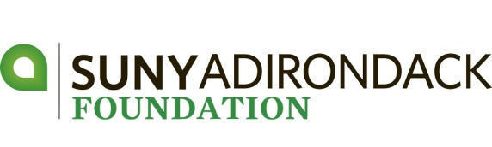

2018 Sponsorship Levels 2018

Prize - $300
- Logo on Prize Envelopes
• Logo on website
Tee Sign - $200
- Sign at Hole
Hole-in-One - $750
- Sponsor of Hole-in-One Prize Hole • Two Golfers
- Listing in Program • Logo on website
Associate - $1,200
- Signage at Putting Contest • Listing in Program
- Golf for Four • Logo on website
Bachelor - $1,500
- Shared sponsorship of lunch • Golf for Four
- Signage on course and program • Logo on website
Master - $2,000
- Choose One Exclusive Sponsorship:
- Bag Drop Off OR Driving Range OR Keg and Water Station OR Silent Auction OR Clubhouse Raffle
- Golf for Four • Signage on course and program
- One drink ticket per player • Logo on website
Doctoral - $2,500
- Choose One Exclusive Sponsorship:
- 19th Hole Award Reception OR Logo on Player Gift Bag OR Beverage Ticket Sponsor OR Logo on Carts
• Logo on Registration • Golf for Four
- Signage on course and program • One drink ticket per player
- Logo on website
Post-Doctoral Sponsor - $4,000
- One $500 scholarship • Logo on Save the Date & Registration
- Logo on player gift • Golf for Four
- Signage on course and program • One drink ticket per player
- Logo on website
Tournament - $5,000
- Two $500 scholarships • Logo on Save the Date & Registration
- Logo on player gift • Golf for Eight
- Signage on course and program • One drink ticket per player
- Logo on website

