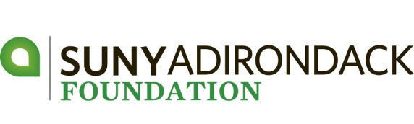

**Sponsorship Levels - 2018**

**Tournament - $5,000**

* Two $500 scholarships • Logo on Save the Date & Registration
* Logo on gift and gift bag • Golf for Eight
* Signage on course and program • One drink ticket per player
* Logo on website

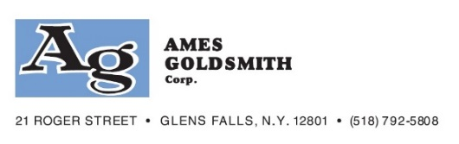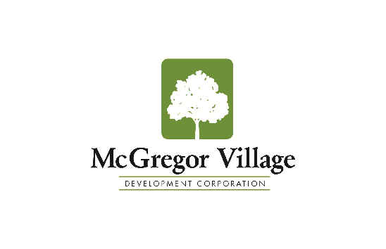

**Tee Sign - $200**

* Sign at Hole

**Prize - $300**

* Logo on Prize Envelopes
* One drink ticket per player • Logo on website

**Hole-in-One - $750**

* Sponsor of Hole-in-One Prize Hole • Two Golfers
* Listing in Program • Logo on website

**Associate - $1,200**

* Signage at Putting Contest • Listing in Program
* Golf for Four • Logo on website

**Bachelor - $1,500**

* Shared sponsorship of lunch • Golf for Four
* Signage on course and program • Logo on website

**Master - $2,000**

* Choose One (Sponsorship):
* Bag Drop Off **OR** Driving Range **OR** Keg and Water Station **OR** Silent Auction **OR** Clubhouse Raffle
* Golf for Four • Signage on course and program
* One drink ticket per player • Logo on website

**Doctoral - $2,500**

* Choose One:
* Logo on carts **OR** 19th Hole Award Reception **OR** Logo on Player Gift Bag **OR** Beverage Ticket Sponsor

• Logo on Registration • Golf for Four

* Signage on course and program • One drink ticket per player
* Logo on website

**Post-Doctoral Sponsor - $4,000**

* One $500 scholarship • Logo on Save the Date & Registration
* Logo on gift • Golf for Four
* Signage on course and program • One drink ticket per player
* Logo on website